Nama : Rozan Anggitan

QE - A

Basic Programming

SOAL PRIORITAS 1

1. Source Code :

public class prioritas1no1 {

public static void main(String[] args) {

//luas bangun datar segitiga

float alas = 20;

float tinggi = 25;

float luasSegitiga = 0.5f \* alas \* tinggi;

//luas bangun datar persegi panjang

int panjang = 40;

int lebar = 6;

int luasPersegiPanjang = panjang \* lebar;

//luas bangun datar lingkaran

double jari2 = 7;

double phi = 3.14;

double luasLingkaran = phi \* jari2 \* jari2;

//keterangan hasil

System.out.println("Luas segitiga adalah: " + luasSegitiga);

System.out.println("Luas persegi panjang adalah: " + luasPersegiPanjang);

System.out.println("Luas lingkaran adalah :" + luasLingkaran);

}

}

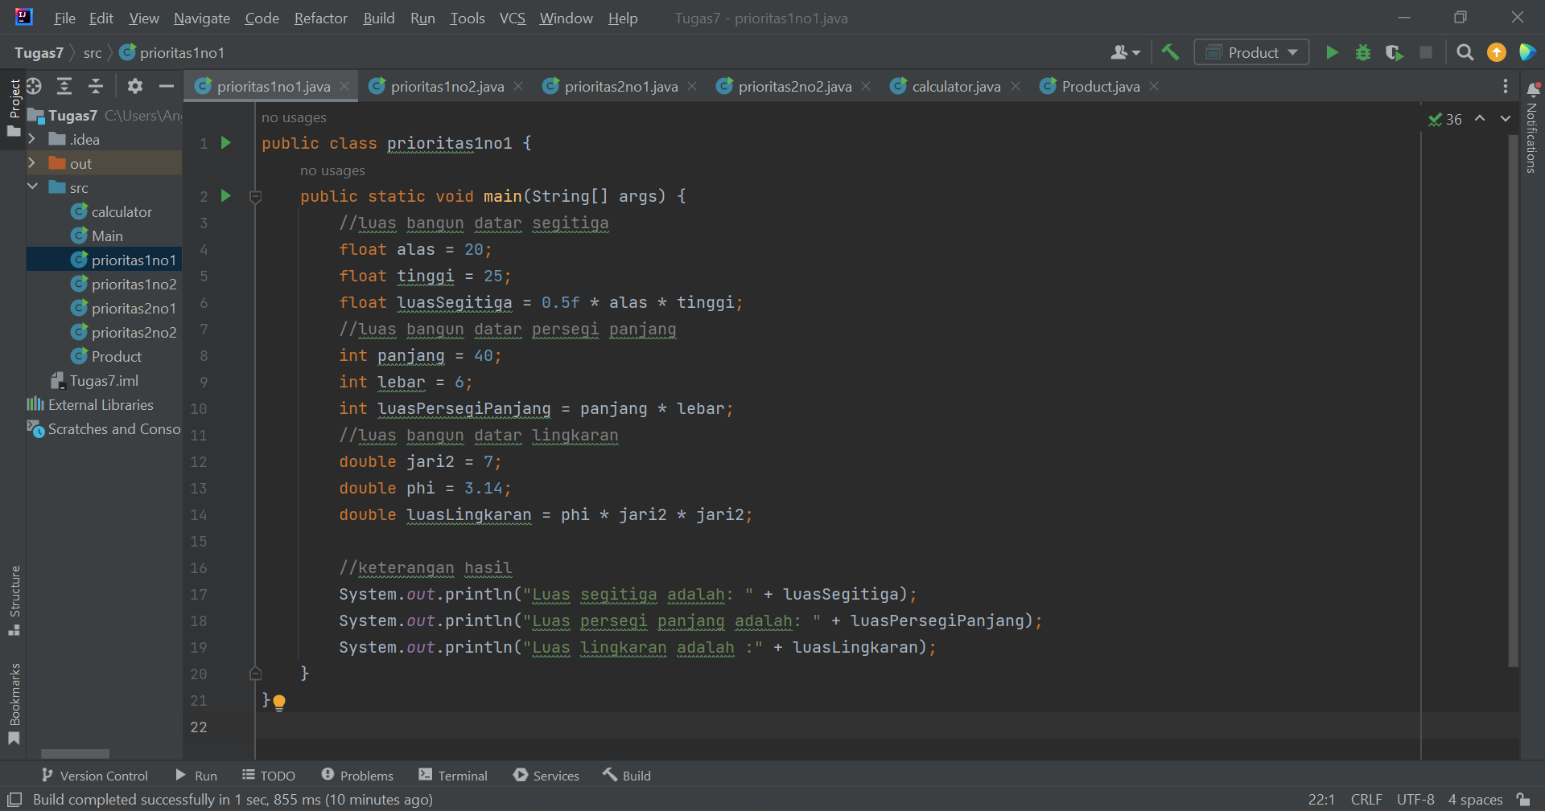

Output :

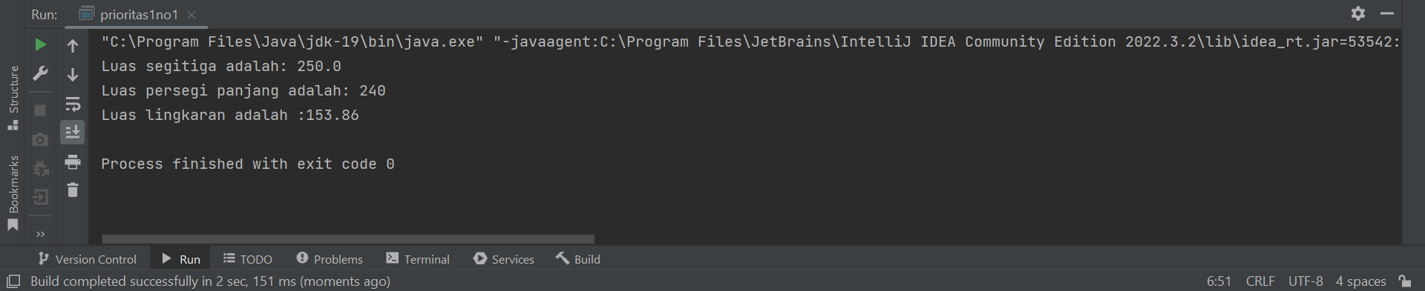

1. Source Code :

import java.util.Scanner;

public class prioritas1no2 {

public static void main(String[] args) {

int hargaBeli = 0;

int hargaJual = 0;

int hasil = hargaBeli-hargaJual;

String keterangan;

Scanner harga = new Scanner(System.in);

System.out.println("Masukan Harga Beli : ");

hargaBeli = harga.nextInt( );

System.out.println("Masukan Harga Jual : ");

hargaJual = harga.nextInt( );

if (hargaJual > hargaBeli){

keterangan = ("Untung sebesar : " + (hargaJual-hargaBeli));

} else if (hargaJual < hargaBeli) {

keterangan = ("Rugi sebesar : " + (hargaJual-hargaBeli));

}

else

{

keterangan = "Sama Saja";

}

System.out.println(""+keterangan);

}

}

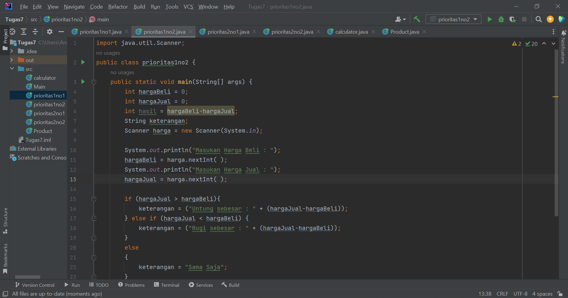

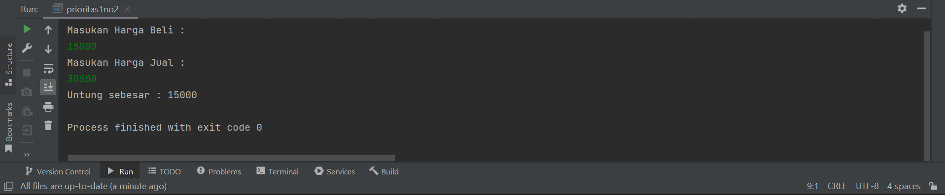

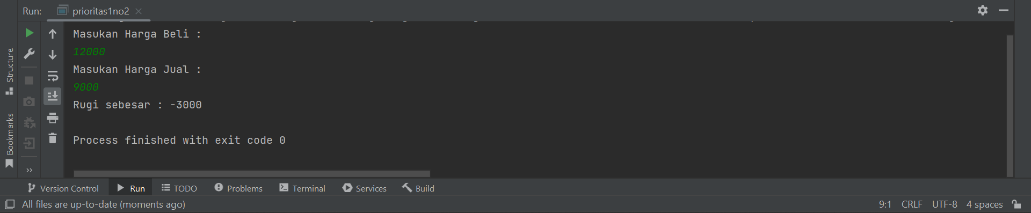

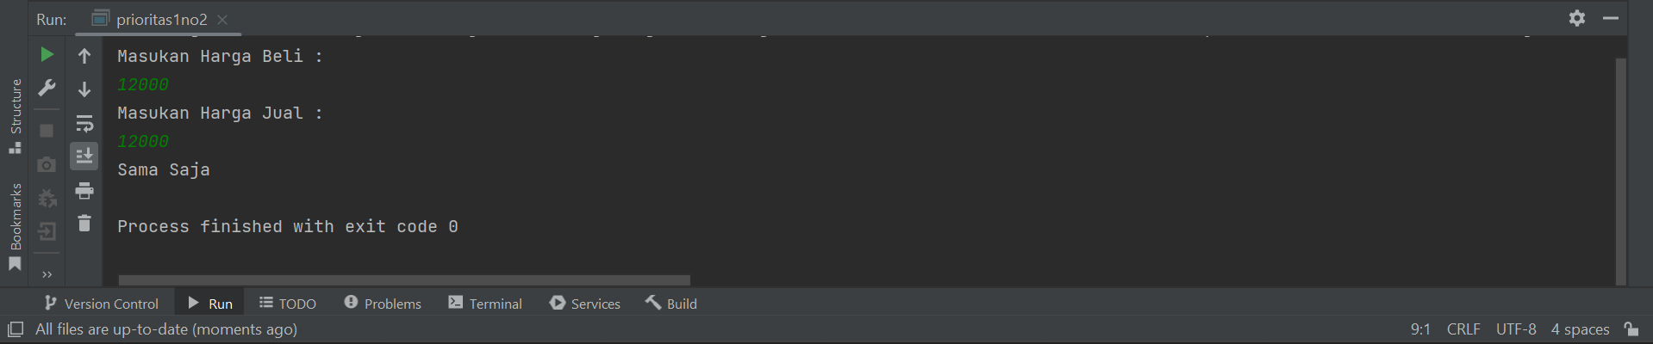

SOAL PRIORITAS 2

1. Source Code :

public class prioritas2no1 {

public static void main(String[] args) {

int height = 5;

int length = 5;

int count = 1;

for (int i = 1; i <= height; i++) {

for (int j = 1; j <= length; j++) {

if (count % 3 == 0) {

System.out.print("X ");

} else if (count % 2 == 1) {

System.out.print("Y ");

} else {

System.out.print("Z ");

}

count++;

}

System.out.println();

}

}

}

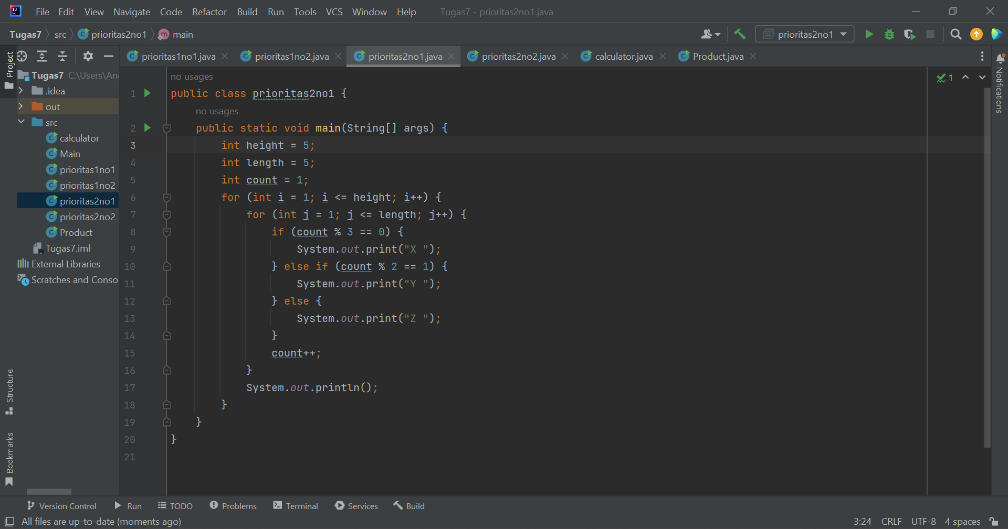

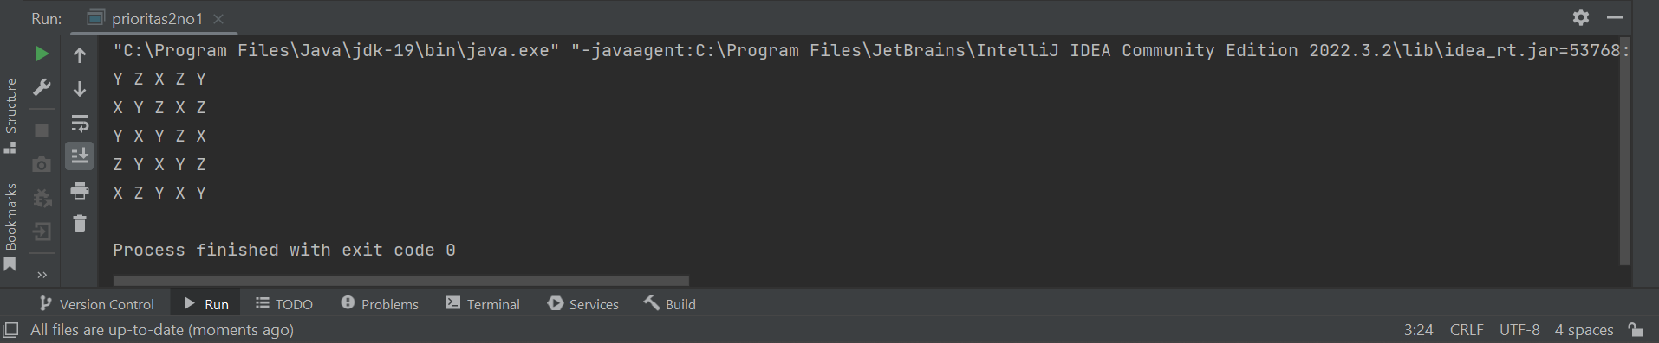

1. Source Code :

public class prioritas2no2 {

public static void segitigasterik(int n) {

for (int i = 1; i <= n; i++) {

for (int j = 1; j <= n - i; j++) {

System.out.print(" ");

}

for (int k = 1; k <=1\* i - 0; k++) {

System.out.print("\*");

}

System.out.println(" ");

}

}

public static void main(String[] args) {

segitigasterik(5);

}

}

